***Steam Power Plant***

* **Introduction:**

The Rankine cycle is a model used to predict the performance of steam turbine. It was also used to study the performance of reciprocating steam engines. The rankine cycle is an idealized thermodynamic cycle of a heat engine that converts heat into mechanical work while undergoing mechanical work while undergoing phase change. Diagram is shown in figure.

* **Parts list:**
* Tachometer
* Temperature indicator
* Break load indicator
* Break cooling water control
* Steam solenoid valve
* Throttle valve
* Impulse turbine
* Guage
* Safety valve
* Boiler level indicator
* Nozzle
* **Tachometer :**

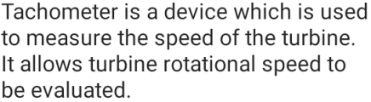

* **Temperature indicator:**

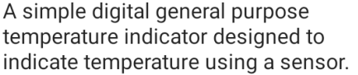

* **Break cooling water control:**

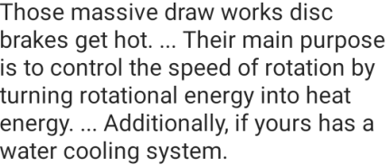

* **Break load indicator:**

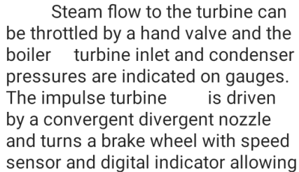



* **Steam solenoid valve:**

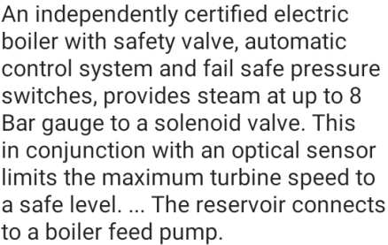

* **Impulse turbine:**

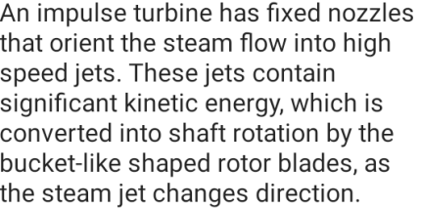

* **Throttle valve:**

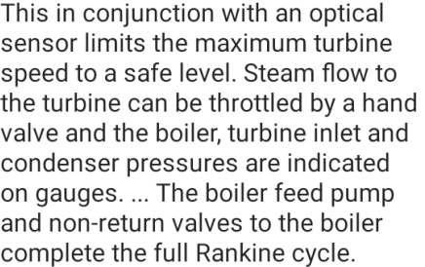

* **Gauge:**



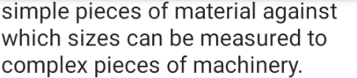

* **Safety valve:**

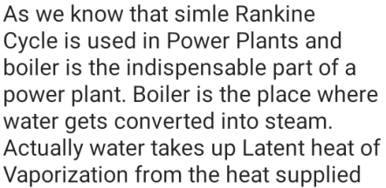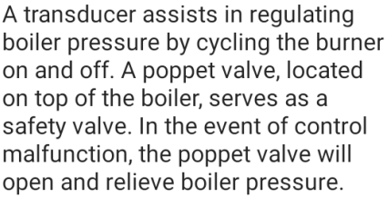

* **Boiler terminal:**

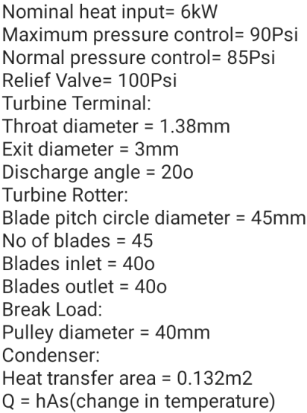



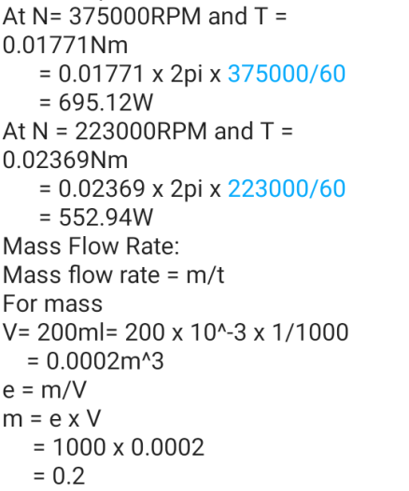

**Diagram of steam power plant:**

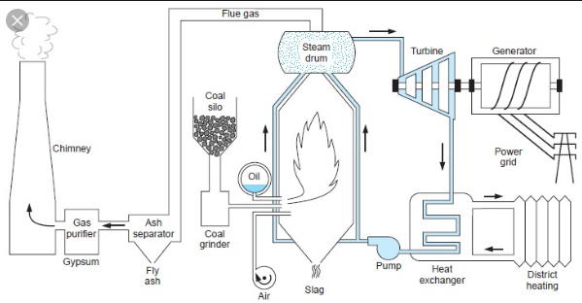

* **Ts diagram:**

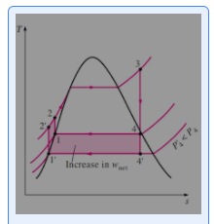

* **Pv diagram:**

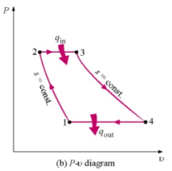

* **Applications:**

